1. INTRODUCTION :-

* 1. Overview:

This above session that introduces bank financial statements and provides the traditional, ratio-based procedure for the analyzing bank financial performance using historical data. It demonstrates the interrelationship between the income and the balance sheet statement and describes the risk and return trade-off underlying management decisions. Data are provided that compare the performance characteristic of small banks versus large banks and differentiate between high and low performers.

Financial analysis is the process of examining a company performance in the context of its industry and economic environment in order to arrive at a decision or recommendation. Overall, a central focus of financial analysis is evaluating the company’s ability to earn a return on its capital that is at least equal to the cost of the capital, to the profitably grow its operations, and to generate enough cash to meet obligations and pursue opportunities.

Fundamental analysis is the information start with founds of the company reports. These financial reports include audited financial statements, additional disclosures required by the regulatory authorities, and any accompanying commentary by the management.

* 1. Purpose:

The financial analysis aims to analyze whether an entity is stable, liquid, solvent, or profitable enough to warrant a monetary investment. It is used to evaluate economic trends, set financial policies, build long- term plans for the business activity, and identity projects or companies for investment.

1. PROBLEM DEFINITIONS & DESIGN THINKING:-
   1. Empathy Map:

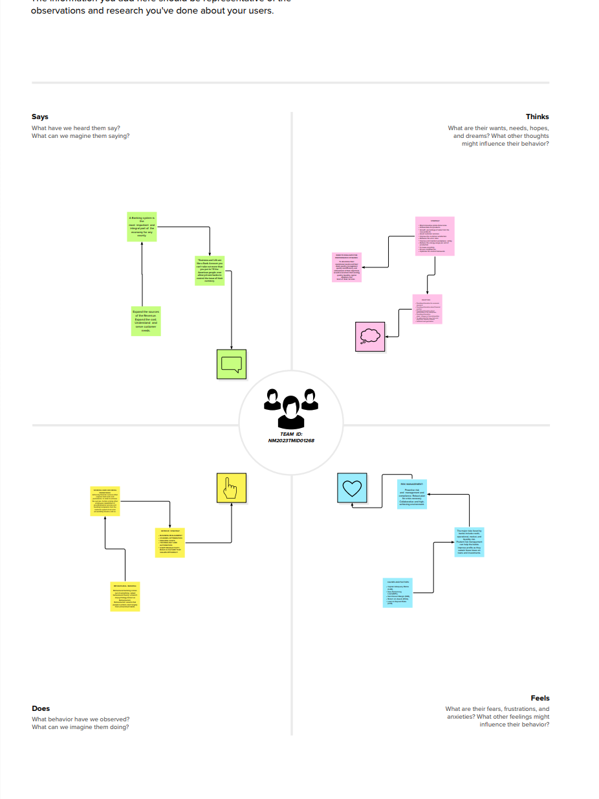

Ideation & Brainstorming Map:

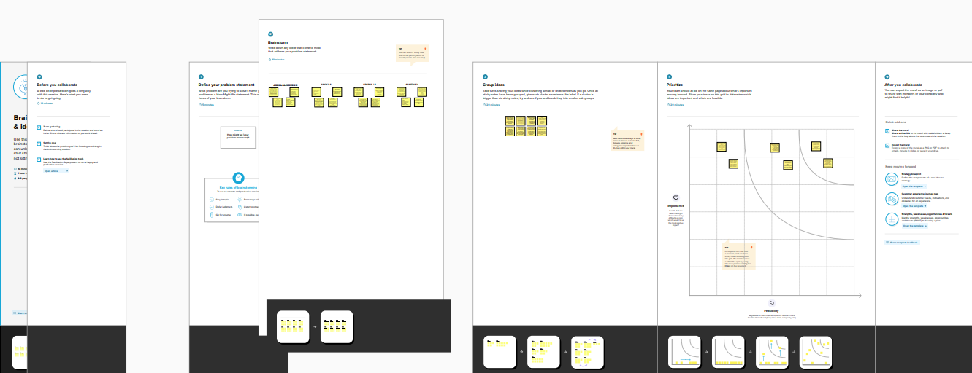

1. RESULT:-

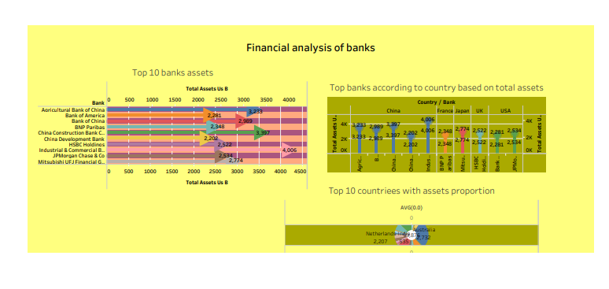

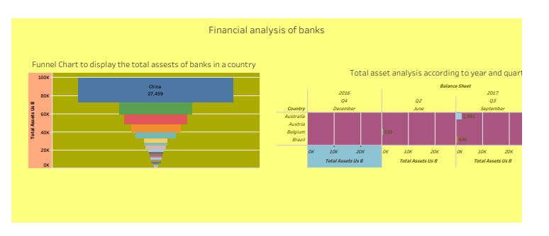

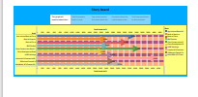

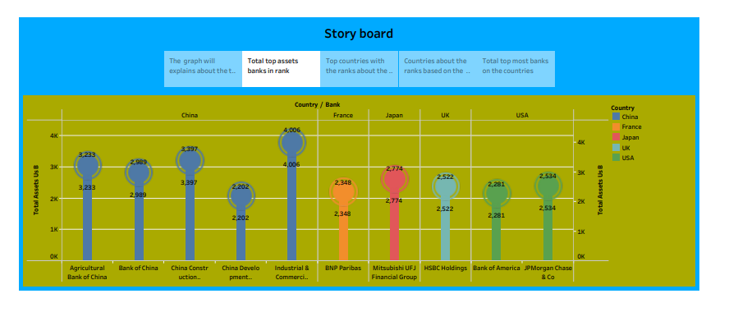

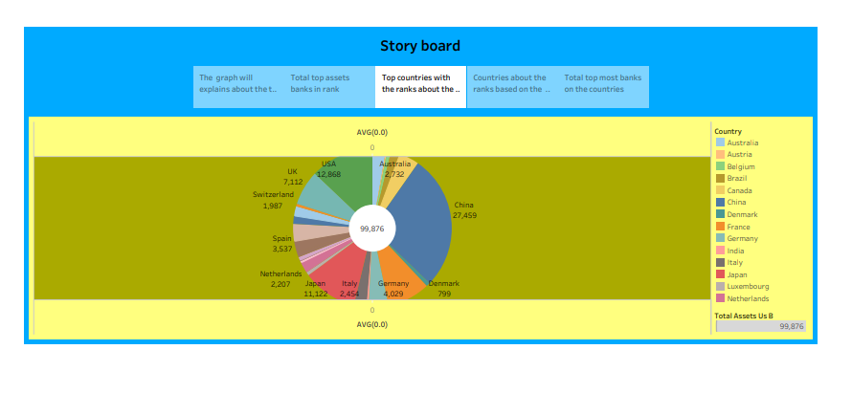

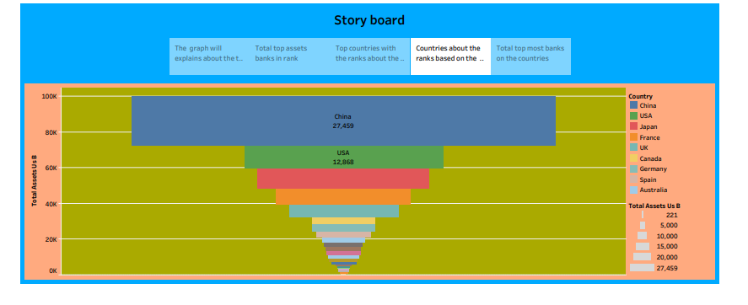

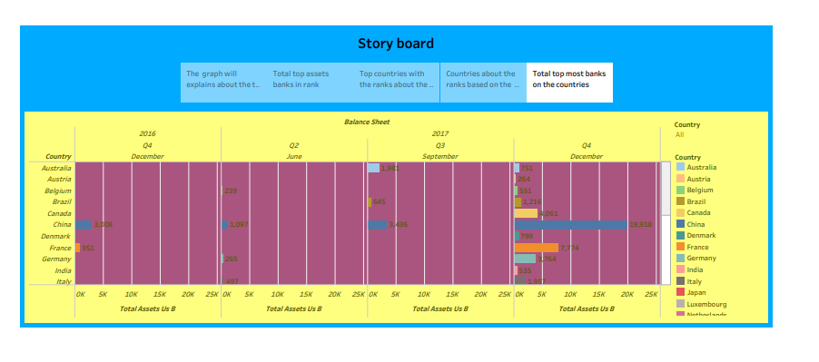4. ADVANTAGES & DISADVANTAGES:-

Advantages:

* The most important benefit if financial statement analysis is that it provides an idea to the investors about the deciding on investing their funds in a particular company.
* Another advantage of financial statement analysis is that regulatory authorities like IASB can ensure company following the required accounting standards.
* Financial statement analysis is helpful to the government agencies in analyzing the taxation owed to the firm.
* Above all, the company is able to analyze its own performance over a specific time period.
* Helpful to evaluate past performance.
* Helps to make credits decision.
* Helpful for future planning.
* Helps management to make decisions.
* Helpful to determine the tax liability.
* Helps to predict future performance.

Disadvantages

* Financial statements are only interim reports.
* Items are based on personal judgement.
* Non-monetary factors are excluded.
* Ignores the changes in price level.
* It is records of past events only.
* Measurement problems and short-term concentration are two drawbacks of financial performance measurements.
* Communications may become challenging as a result.
* It requires the investments plans and they are somewhat complicated also, it needs a whole lot of financial knowledge.

1. APPLICATIONS:-

Financial ratios can be computed using data found in financial statements such as the balance sheet and income statement . In general, there are four categories of ratios analysis:

\* Probability

\* Liquidity

\* Solvency

\* Valuation

\* Retirement strategy

\* Risk Management plan

\* Long-term investment plan

\* Tax reduction strategy

Main Applications:

\* Payments gateways

\* Budgeting apps

\* Financial forecasting apps

\* Tax management software

\* Contextualized analytics

\* Codeless analytics

\* Real-time insights

\* Log analytics

\* Big data capability

1. CONCLUSIONS:-

* Banks assets can generally be classified in one of four categories: Cash and equivalents, investment securities, loans and other assets. Liabilities include transactions accounts time and savings deposits, purchased liabilities , such as federal funds purchased and jumbo CDs, and long-term debt. Stockholders equity represents ownership interest in the bank.
* A bank’s net income can be divided into four components that potentially reveal differences in performance: net interest income, provisions for loans loses, burden and taxes.
* There are seven fundamental risks in banking: credit risk, liquidity risk, interest rate risk, capital risk operational risk, off-balance sheet risk, and foreign exchange risk.
* There is fundamental trade off- between bank profitability and risk. A bank that reports above average profits either takes on above average risk or realize a competitive advantages in offering some product or service.
* The Uniform Bank Performance Report (UBPR) is available quarterly for anyone to evaluate a banks risk and return performance.
* The primary purpose of financial reports is to provide information and data about a company financial position and performance, including profitability and cash flows.
* The primary financial statements are the statement of financial position.

1. FUTURE SCOPE:-

The nature of the Indian economy over the last few years has been dicey. Big brands names and the economy, reputed firms are forced o- shut down or sack thousands of employees. There is no job security. This is a major reasons why people in large numbers today choose to go for banks jobs instead.

The banking sector mainly recruits for three posts – clerical cadre, Management and Trainee (MT), and Probationary Officer (PO).

Other opportunities in this career path are financial service representative bank tellers, bill and account collectors and loan officers financial managers bookkeeping and audit clerks.

Also possess the following traits:-

* Good analytical skills
* Good communication skills
* Ability to function in a high-pressure situation
* Interpersonal skills

CAREER GROWH AND PROMOTIONS:

The various positions in a bank states below:

* TOP MANAGEMENT

\* President

\* Chief Executive Officer

\* Chief Financial Officer

\* General Manager

\* Deputy General Manager

* SENIOR MANAGEMENT

\* Assistant General Manager

\* Chief Manager

* MIDDLE MANAGEMENT

\* Senior Manager

\* Manager

* JUNIOR MANAGEMENT

\* Probationary Officer

\* Clerk